It is an honor and a privilege to serve as a Texas ENA Delegate. Delegates serve in a capacity that helps shape the organization's direction by representing our state at the annual ENA General Assembly. Delegates must meet the criteria set forth by the National ENA Bylaws.

Application Description

TXENA Delegates are selected using a point system. Points are accumulated for holding elected office and committee activity from January 1, 2026, through May 31, 2026. Additional points are awarded for meeting attendance at the Texas ENA general assembly, chapter meetings, and other activities, such as voting in the national ENA election, writing publications or speaking on behalf of ENA, from June 1, 2025, to May 31, 2026. Points are also awarded for current specified certifications and ENPC or TNCC provider/instructor/course director activity. To accumulate points for Texas ENA meetings attended, members must be in attendance for the majority of the meeting. Local meeting attendance, local elected office, and committee activity must be verified by the chapter president. Delegates will be ranked by points to fill the available delegate positions. The State President is automatically seated as a Texas ENA delegate.

Each section of the application has a maximum number of points. You will need to enter the points assigned to the items you select in the space provided. The application will automatically add your points for each section, limit your total allowable points, and display the total at the end. It is your responsibility to check your work. At the end of your application, be sure to review your answers.
We know our application process has changed! Please reach out to your Delegate Selection Chair, Vice Chair, or TXENA leadership for questions or clarification.

Delegate Requirements and Responsibilities:

1. Be a Texas ENA member in good standing from June 1, 2026 to October 31, 2026, to participate as a delegate in the General Assembly. Proof of current membership is required.

2. As a delegate, you must complete the Delegate General Assembly Orientation online module on the ENA website. (A link will be sent to you via email in advance.)

3. Attend the Texas State Delegates Meeting the day prior to General Assembly (date and time to be established in advance). You will be notified by email as soon as this information is available.

4. Be on time and attend the entire two days of the General Assembly meeting.

5. Comply with the Texas ENA Delegate dress code. Official delegate shirts and black pants or skirts are to be worn both days. No leggings or blue denim jeans allowed.

6. Professional conduct is required at all times while officially representing Texas ENA during the General Assembly.

7. Experienced delegates may be asked to serve as a mentor to new delegates. As a new delegate, you will be introduced to a mentor to assist you in becoming familiar with the delegate process.

8. I understand that I will need to make my own travel and hotel arrangements.

9. As a delegate/alternate, you may be required by the Texas State Board or Committee to work at the state booth at the national convention or perform tasks related to state functions during the national convention.

10. All delegates will be required to complete a Texas ENA expense report with required receipts within 30 days of the end of general assembly. If the appropriate expense report is not received, delegates will not receive their reimbursement checks. Keep your receipts!

11. I understand that any stipend check I receive to help cover my expenses is contingent on meeting these requirements.

NOTE: Delegate stipend checks will NOT be issued in advance. Delegates CAN include expenses incurred while attending EN26.

Section Instructions:

APPLICANT INFORMATION:
- Applicant Name
- Chapter (Choose your TXENA Chapter from the drop-down list)
  - Austin
  - Brazos
  - Central Texas
  - Dallas County
  - East Texas
  - Golden Triangle
  - Gulf Coast
  - Hi Plains
  - Houston Chapter
  - North Texas
  - Rio Bravo
  - San Antonio
  - Staked Plains
  - Tarrant County
  - Texas 10-59
  - West Texas Panhandle

- Home Address:
- City, State, Zip:
- Telephone:
- Email:
- ENA Membership number:
- Expiration date, Life members enter 01/01/2099

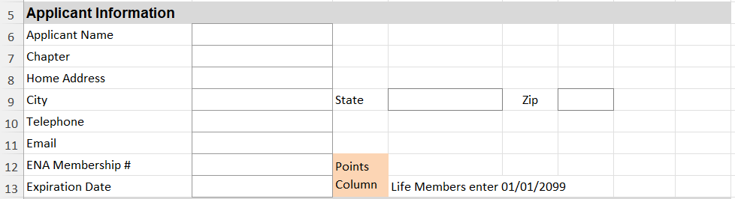

SECTION 1. Elected Positions held during January 1, 2026 - May 31, 2026.
Please select the appropriate position from the dropdown.
Section Limit: 12 points. Point values are listed next to each choice.
Enter points for the Local office held in the points column.
Repeat on the next line for the State office held.
- None (0)
- President (6 pts)
- President Elect (6 pts)
- Past President (6)
- Secretary (6 pts)
- Treasurer (6 pts)
- Director (6 pts)
- FAEN (6)
- Foundation Trustee (6)
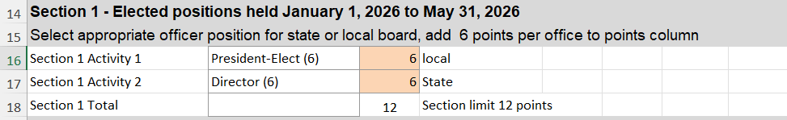

SECTION 2. Committee Positions held during January 1, 2026 – May 31, 2026
Please select the appropriate committee position from the dropdown.
Repeat for the number of committee positions held you would like to submit.
Section Limit: 14 points. Point values are listed next to each choice. Enter points for the chosen committee position in the points column.
List Committee Title in the space provided.
NOTE: You may NOT accumulate points as both the Chair and as a member of the same committee.
- None (0)
- National Chair (8)
- National Member (6)
- State Chair (6)
- State Member (4)
- Local Chair (6)
- Local Member (4)
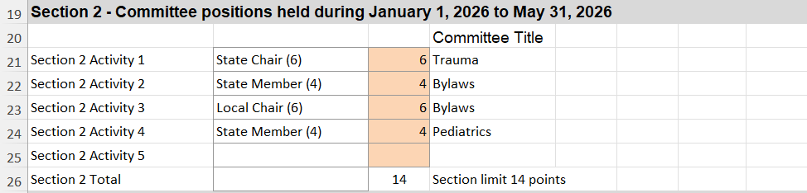

SECTION 3. Local Chapter Meeting Attendance from June 1, 2025, to May 31, 2026.
Please select the appropriate chapter meeting from the dropdown menu.
Repeat for the number of meetings you attended.
Indicate the month in the space provided.
Section Limit: 18 points. Point values are listed next to each choice. Enter the points in the points column.
Enter the MONTH in the space provided.
1. None (0)
2. Monthly Meeting (2)
2. Bi-Monthly Attendance (4)
3. Quarterly Attendance (6)
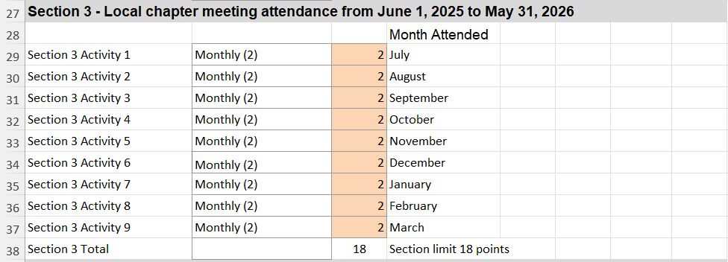

SECTION 4. National/State Meeting Attendance from June 1, 2025 – May 31, 2026.
Please select appropriate attendance at each meeting/event from the dropdown.
Repeat for the number of meetings you attended.
Section Limit: 22 points. Point values are listed next to each choice. Enter the points in the points column.
SUBMIT a copy of your EN25 registration or CEU certificate
1. National General Assembly Delegate / Alternate 2025 (4 points)
2. EN25 (4)
3. State Meeting: July 2025 (4)
4. State Meeting: October 2025 (4)
5. State Meeting: January 2026 (4)
6. State Meeting: April 2026 (4)

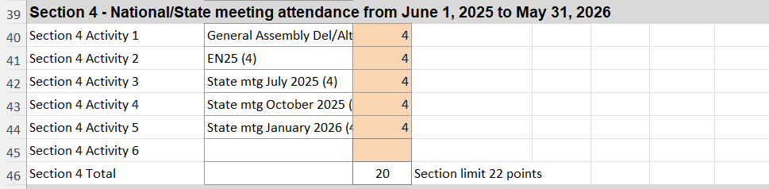

SECTION 5. Certifications
Please select the appropriate certification from the dropdown.
Repeat for the number of certifications you possess.
Section Limit: 14 points. Point values are listed next to each choice. Enter the points in the points column.
Note: May not claim two certifications in one criterion, e.g., TNCC course director and TNCC faculty (Claim the higher level).
For Other Certifications, indicate the name of the certification to the right. Basic certifications such as BLS, ACLS, or PALS are not accepted.
SUBMIT a copy of the credential verification (certificate).
1. ENPC Provider (1)
2. ENPC Instructor (2)
3. ENPC Course Director (4)
4. ENPC Faculty (6)
5. TNCC Provider (1)
6. TNCC Instructor (2)
7. TNCC Course Director (4)
8. TNCC Faculty (6)
9. TNAC Provider (1)
10. TNAC Instructor (2)
7. Course Director certification Review (4)
8. SANE (4)
9. CEN (6)
10. CPEN (6)
11. CTRN (6)
12. CFRN (6)
13. CBRN (6)
14. TCRN (6)
15. Other Cert (2)

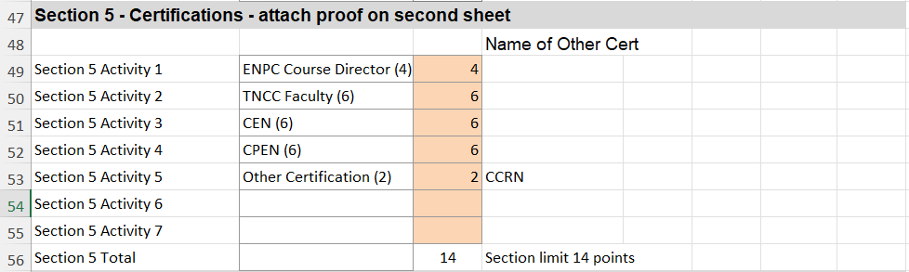

SECTION 6. Other Activities from June 1, 2025 - May 31, 2026.
Please select the appropriate activity from the dropdown menu.
Repeat for the number of activities.
Section Limit: 20 points. Point values are listed next to each choice. Enter the points in the space provided next to your chosen item.
1. EN26 Leadership Volunteer (4)
2. Voted in National Election (2)
3. Published National (6)
4. Published State (4)
5. Published Local (2)
6. Speaker National (6)
7. Speaker State (4)
8. Speaker (2)
9. PRISM (4)
10. PECC (2)
11. Specially Appointed Position (4)

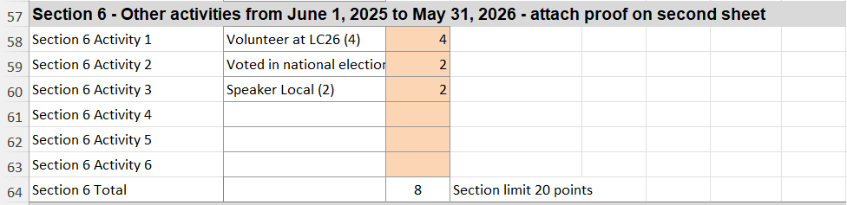

TOTAL POINTS: Your points will be automatically calculated and displayed at the bottom.
Are you a Prior GA Delegate? Would you like a GA Mentor?
Verification and Signatures
Applicant Signature
Applicant Date
Chapter President Signature
Chapter President Date
Delegate Selection Reviewer

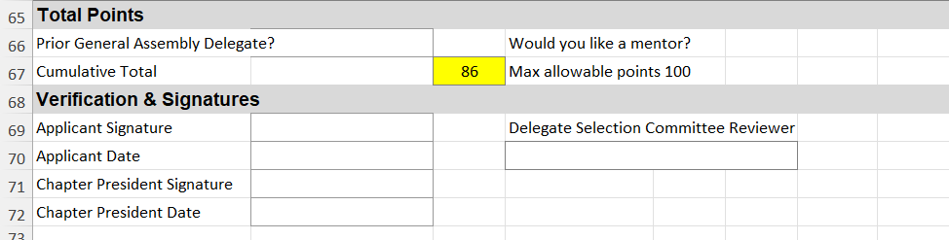

Attachments: Screenshot all required proofs and place them in a single PDF or Word file. Submit these files with your application.

NOTE: The Chapter President must verify all local activities, sign and date the application before the applicant sends the application form to the Delegate Selection Committee Chair at
Delegate.selection@txena.org

INSTRUCTIONS FOR THE CHAPTER PRESIDENT and APPLICANT to VERIFY LOCAL ACTIVITIES.
- Applicants must send completed application to the Chapter President on or before May 25, 2026.
- The Chapter President must verify the following local information for accuracy.
  - Elected Positions (Section 1)
  - Committee Positions (Section 2)
  - Chapter Meeting attendance (Section 3)
- After verifying local information to be accurate, the Chapter President signs and dates the Application form.
- The verified application must be sent to the Delegate Selection Committee Chair at Delegate.selection@txena.org on or before June 1, 2026.
- Please DO NOT WAIT for deadlines, submit application as early as possible. Applications received after the deadline will not be considered.
- The Delegate Selection Committee Chair will send confirmation email that the application was received. If no confirmation email was received after 2 days, the applicant may reach out to the Delegate Selection Committee.

