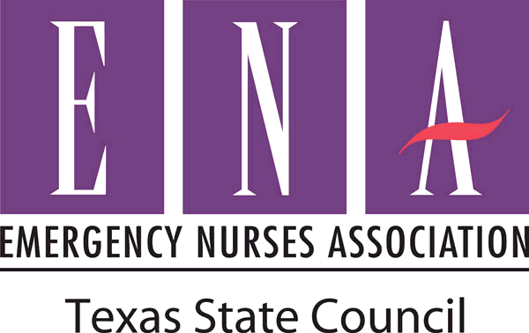
Position Statement

Nursing Home Hand-Off Reports to Emergency Departments

Description
The population of the United States will include 35% of individuals over the age of 65³. There are roughly 6.1 million individuals currently residing in nursing homes, skilled nursing facilities, or specialized nursing units¹. Research has found that a nursing home resident has a 60% chance of being transferred to an emergency department and a 30% chance of being admitted to a hospital in a 1-year period (McCloskey, 2011).
Emergency departments continue to express concern regarding poor or lack of communication between skilled nursing facilities for patients being transferred into their facility. The lack of coordinated hand off tools or devices increase the risk of adverse reactions to medical treatments provided that otherwise could have been prevented.
Continuity of care delivery is a paramount need for patient safety. Due to the co-morbidities that underlay this patient population, poor or lacking communication increases their risk for medical errors and creates an unsafe patient delivery of care. In an emergency situation the more information obtained prior to care is a vital component of this need for continuity and patient safety. The American Medical Directors Association (AMDA) Resolved, March 2010 that the transfer of individuals residing in skilled nursing facilities requiring transfer to an acute care facility should focus on: patient centered care, communication, and safety⁵. The AMDA’s focus on communication include: information about the patient, including their medications as well as actively working with other relevant professionals to create and improve policies and procedures that assure timely and accurate information, as well as communication about transfers from professional to professional in different sites of care⁵.
Although The Joint Commission requires accredited organizations to use a standardized approach to handoff communications, approximately 80% of serious medical errors occur due to high miscommunication rates during patient hand-offs/transfers³.

Position Statement

Texas ENA Position
It is the position of the Texas Emergency Nurses Association that:
- Poor communication between facilities can lead to an increased risk of negative healthcare outcomes.

- The development and use of standardized reporting methods provide safe and effective continuity of care.

- Emergency Departments should communicate and coordinate educational programs to area facilities using a standardized transfer report.

- When report is received, either verbally or written, the name of the facility, nurse providing report, and call back telephone numbers should be included for effective discharge planning.

- Emergency Departments compel their nursing home partners in utilizing their industry standard of transfer/hand off report established by the American Medical Directors Association: INTERACT II transfer tool⁷ or the Emergency Nurses Association’s Safer Handoff Transfer Form⁶.

Background
The delivery of care in emergency departments work towards a curative model of care focused on stabilizing an acute versus an acute on chronic condition. In sharp contrast, nursing homes focus on supportive measures of daily routines. Routinely in nursing homes across the United States patients are transferred to emergency departments for acute or acute on chronic conditions requiring new or advanced medical interventions not provided at their current setting. It is estimated that a percentage of these individuals are transferred without proper communication between nursing staff to ensure adequate medical information, such as medications administered, allergies, or medical and surgical conditions. Even greater number of individuals presenting to emergency departments via emergency transport services have no recollection of medical or surgical history, nor their medications they are currently prescribed or have recently taken. It is in the best interest of all parties, sending and receiving facility as well as the patient to receive proper communication to ensure safe and efficient care.

Position Statement

References
- Boockvar, K.S., Burack, O.R. (2007). Organizational relationships between nursing homes and hospitals and quality of care during hospital-nursing home patient transfers. Journal of the American Geriatrics Society, 55:1078-1084.
- McCloskey, Rose (2011). The ‘mindless’ relationship between nursing homes and emergency departments: what do Bourdieu and Freire have to offer? Nursing Inquiry, 18(2): 154-164.
- McCloskey, Rose (2011). A Qualitative study on the transfer of residents between a nursing home and an emergency department. Journal of the American Geriatrics Society, 59: 717-724.
- Pearson, K.B., & Coburn, A.F. (2013). Emergency Transfers of the elderly from nursing facilities to critical access hospitals: opportunities for improving patient safety and quality. Office of Rural Health Policy. Policy Brief #32.
- American Medical Directors Association. (n.d.). Improving care transitions between the nursing facility and the acute care hospital setting. Public Policy Committee Resolution H 10.
- Emergency Nurses Association: Safer Patient Transfer Form. Taken from: http://enascratch.f648.net/practice-research/practice/safety/patient/pages/saferhandoff.aspx.
- American Medical Directors Association: INTERACT II. Taken from: https://interact2.net

Developed: July 2014
Approved by the Texas ENA Board of Directors: July 2014

