TEXAS ENA MEETING AGENDA

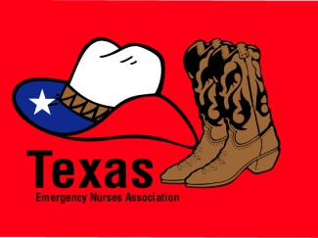 [Work Team/Committee Name]
April 21-22, 2011 Meeting
Work Team Members
Fred Jones, RN, MSN, CEN Chairperson
Susan Smith, RN, BSN, CEN
Jacob Williams, RN, MSN, FNP-BC, FAEN

Board Liaison
Bob O’Reilly, RN, MSN, CEN, FAEN

Staff Liaisons
Sarah Zielinski, RN, PhD, Director of Research
Robert Garcia, MPH, Senior Research Associate
Kim Patel, Senior Administrative Assistant

AGENDA

Thursday, April 21, 2011: 12:00 p.m. – 4:00 p.m. (Working lunch provided by ENA)
- Welcome/Review Roster/Approve Minutes (12:00 – 12:15) Jones
- Review Charges (12:15 – 12:30) Jones
- Insert Text Here (12:30 – 2:30) All
  - Insert Text Here
    - Insert Text Here
    - Insert Text Here
  - Insert Text Here
  - Insert Text Here
BREAK (2:30 – 2:45)
- Insert Text Here (2:45 – 4:00) All

Friday April 22, 2011: 8:00 a.m. – 4:00 p.m. (Lunch provided by ENA)
- Insert Text Here (8:00 – 9:00) All
- Insert Text Here (9:00 – 10:15) All
BREAK (10:15 – 10:30)
- Insert Text Here (10:30 – 12:00) Smith
LUNCH (12:00 – 12:45)
- Insert Text Here (12:45 – 2:45) All
BREAK (2:45 – 3:00)
- Insert Text Here (3:00 – 3:30) Jones
- Next Steps/Action Items (3:30 – 4:00) Jones
- Complete Assignments Table
- Adjourn (4:00)

Assignments Table
Item | Assigned To | Due Date

