Texas Emergency Nurses Association

Chapter Guidelines for Planning and Hosting Quarterly State Council and Board Meetings

Provided by
The Meeting Planning Committee

Updated July 2014

Table of Contents

- Introduction
- Meeting Dates
- Planning Schedule
- Financial Considerations
- Choosing a Site
- Negotiating a Contract with the “Host Hotel”
- Room Requirements / Room Set-Ups / Diagrams
- Food Requirements

- Introduction
Congratulations on your decision to host one of our Quarterly State Council Meetings!

Whether this is the first time your chapter has hosted or you have a lot of experience hosting one of these meetings, the Meeting Planning Committee is here to help you.

Each of our Quarterly meetings present their own “individual” challenges. The challenges are due to the time of the year, and all of the other activities that may be going on either before, during or after the meeting.

The First Quarter meeting (January) includes the State Leadership meeting. This meeting is our largest, most highly attended meeting with most attendees arriving on Thursday. This meeting falls right after the “Holiday Season” and that presents some “challenges” with the planning process. It is mandatory that the hotel for the January meeting be selected and booked before Thanksgiving.

The Second Quarter (April) meeting usually falls close to “Spring Break” and that can be problematic with finding hotel rooms, so please book early.

The Third Quarter (July) meeting comes during “Summer Vacation”; this can also result in increased room costs and increased travel expense for the attendees.

The Fourth Quarter (October) meeting comes after the ENA General Assembly and Scientific Assembly. It is also the meeting in which:
1.) We elect the Board of Directors for the TXENA for the following year;
2.) We begin our Strategic Planning and
3.) Finalize the budget process.

Each “host chapter” should have their own local planning committee and site coordinator/contact person.

- Meeting Dates
Quarterly Meeting dates and host chapters are selected at least 12 months in advance, with exact dates posted, in order to give the Host Chapter time to plan.

If your chapter has offered and has been selected to host a quarterly meeting by the Meeting Planning Committee, you will need to keep the Meeting Planning committee up-to-date on the planning process.

3. Planning Schedule
- Your chapter must select a person to attend the Meeting Planning Committee Quarterly meeting
- Organize your local Meeting Planning Committee. Designate the contact person for your chapter’s meeting and send that information to the chair of the Meeting Planning Committee.
- Contact the Meeting Planning Chair for help with planning and possible resources.
- Contact your local Visitor’s Bureau, or City Visitor Center.
  - These people can assist you in finding possible locations for your meeting. They may have suggestions for places that you have not previously considered. Best of all, this is a free service! They can supply you with “tourist information and discount coupons to your area.” Let them know when the meeting is taking place and they will help you contact the people that you need to talk to!
  - Please don’t wait until the last minute to start making contacts! If you plan far enough in advance you can sometimes lock in prices before any “unexpected” price increase.
- Arrange for “block of rooms” at a local Hotel. You need to look at what a “block of rooms” entails. If you are planning the event at the host hotel, they may ask you to guarantee a minimum number of rooms, or a minimum amount for Catering Services. You will need to block approx. 30 rooms. Make sure you allow for hotel accommodations the night before a meeting and the Saturday night afterwards.
  - Most hotels and other venues have a cancellation policy in the contract. You need to be familiar with the deadlines. There is also a deadline to use any “blocked rooms” at a hotel. If the rooms “blocked” are not reserved by the deadline, they will release the block, and any “special pricing” will not apply. Some Hotels are very good about honoring late reservations, but don’t count on it! Our group has 501C3.
  - Most hotels will block rooms at a “reduced rate” until about 14 days before the event. At that point, they will either call you or just release the rooms. That is why it is so important that the “Host Hotel” is posted on the Website at least 30 days in advance of the meeting.
  - When you are talking to the “hotel” people, do it early! Book it before they are busy and increase their prices.
  - There are several different forms of contracts with hotels. Some require a minimum amount of “catering charges” that are attached to the block of rooms that are reserved.

Three Months before the meeting:
Make sure that your meeting dates and hotel arrangements are posted on the Website! It is helpful if that information is available at the State meeting prior to your event.

Two Months before the meeting:
Make sure that all of the meeting information is available to the membership. Confirm with the host facility that the rooms are available, and have a preliminary menu planned. Best prices for airfare are at least 21 days in advance of the meeting.

One Month before the meeting:
Visit the meeting site, review the menu and room set up. Food arrangements are final, with the opportunity to change number of persons in accordance with the venue policy. Most venues will allow you to increase/decrease numbers up to three days before the event. Review all arrangements with the venue to make sure that there don’t have to be final changes. Check with the host hotel as to room availability.

Two weeks before the meeting:
Review the number of expected people for the meeting and make adjustments as needed for the venue/catering. Most catering people plan for about a 3% increase in the number of people that you guaranteed.

Be prepared for “panic” calls, or E-mails from people that have not made their hotel reservations by the hotel deadline! Just deal with them as they come! Most hotels will work with you if they have available rooms. You should probably have a list of “back up hotels” just in case!

One week before the meeting:
Double check the arrangements for the venue and host hotel. Give the final expected numbers for catering. Just remember that the final number is what you are going to be billed for. You don’t want to pay for catering for people that don’t show up. If the number of people increases, that is usually not a problem, as long as you have about 3 days’ notice. If the number decreases, then it is a problem, with the same time constraint. Most catering services plan on about a 3% overage, so there is a small margin for error. Check your contract, make sure that they will be capable of feeding all that show up, and that there is no extra service charge.

You need to know what we can bring in to the meeting, and what the “host facility” requires that they supply.
- Most Hotels will not allow you to bring in “food or beverage” from an outside source, and if they do allow it, there is usually a “Surcharge” added to the bill.

Be honest with your host hotel, and keep them informed of any changes in attendance. They are accustomed to numbers changing at the last minute.

- Financial Considerations
As a “Host Chapter” you assume planning responsibilities, and financial responsibilities, with the State support, as available. The Meeting Planning Committee is ready to support your efforts and give advice and help.

When the State Budget is approved, you will receive allocated budgeted amount for the fiscal year. If your budget exceeds the approved limit, your Chapter will be responsible for any extra expenditure.

Please plan your meetings carefully! Please ask the meeting planning chair to review your budget with you.

- Choosing a Site
This is the most crucial part of planning a meeting! The site has to be easy to reach by the attendee. Hotel costs should be kept as low as possible. It just depends on the designated meeting location, but most people rely on “flying” to these meetings.

The most important considerations in selecting a site for a meeting are:
- Do they have the space available that we need?
- Can they provide that space without breaking the budget?
- Can we book rooms at an affordable rate?
- What services can they offer?

This is the most difficult portion of planning! As the “Host Chapter” you need to make sure that you have provided the facilities that are needed, and also have kept the costs within the projected budget. There are several options available.

Plan the meeting at a “host” hotel.
Benefits
- Usually get a reduced room rate
- Everything is in one location
- Shuttle service is available from the Airport.
- With a “guaranteed” catering fee, room rental is included.
- No additional travel time, the meetings are all held at the host hotel.

Down Side
- Catering costs are high
- Service charges are high
- Extra “service charges” for electrical hook ups and other items

Plan the meeting at a separate location
Benefits
- There may be no room charges for meetings that are held in a host hospital.
- Vendors may be more willing to bring in “food services” if they can arrange that from people other than the hotel.

Down Side
- Room availability at area hospitals
- Transporting people to and from the host hotel(s) to and to and from the site
- Room capacity and availability of needed A/V services may be limited
- Additional travel time needed for people to attend meetings
- You may find it difficult to find a hotel that will allow you to arrange for a “block” of rooms at a reduced rate, if you are not going to use their meeting rooms or Catering services.

We have attended meetings in both formats.

The single most important thing to consider is to make the meeting accessible to all members that attend. Use your budget dollars wisely! Get the most for our dollars. The other consideration is total cost: If you can get the meeting rooms free of charge, and have vendors that are willing to supply a meal, that is great! You will need to read your contract very carefully. Most Hotels or Convention Facilities have Catering Services, and will not allow you to bring in food from the “outside.” If you do have an outside catering service then the Hotel or Convention Facility will probably add a “service charge” for whatever is brought in.

One other “special consideration” is alcoholic beverages. This one can get you in trouble! Some hotels and convention facilities are very strict with this. You really need to read your contract and ask questions before you decide to have a hospitality room and bring in your own “beverages!” Just check with the Hotel or Convention facility and see what their rules and regulations are. We have to remember that if the room is booked in the name of the TXENA, whatever we do can and will reflect on the State Council.

- Negotiating a Contract with the “Host Hotel”
First of all, get several bids!

Don’t be afraid to negotiate. You need to be prepared to talk to these people. The more “facts and figures” that you have to present gives you more options to negotiate. Use the bid process with the Convention Bureau, or the Tourist Bureau. When we have used this process, we have selected three “host facilities,” the Convention Bureau contacts them with the dates and specifics that we have and we have received a “meeting prospective,” from each of the facilities. These include the proposed room rates for overnight stays, an estimate of the costs for room rental for the meeting, catering price list and menus, facility capabilities, minimum required purchases for catering that are usually tied to the amount of meeting space, and an initial “contract.”

Just a note: Watch out for additional charges for “extension cords!” Some facilities charge for each electrical cord that they provide, and most will not allow you to bring in extension cords from the outside. There should be:
- At least two (2) wireless microphones available and
- A projector and screen (or a blank wall) for State Council Meetings.

Read the proposed contract carefully!
- Look at the cancellation policy! Let someone else read the contract also.

- Room Requirements / Setups / Diagrams (see appendix A &B)
State Board Meeting Room:
This will be a smaller version of the State Council Meeting room setup.

State Council Meeting Room:
Basic room set up for a State Council meeting is a U shaped table. The head table needs to seat at least 8 persons with space for lap tops and printers; you also need to make sure that there is an electrical outlet for these devices. There needs to be a minimum of 16 chairs on each side of the room for the Chapter Delegates. We have a possibility of 32 Chapter Delegates for each meeting. We should also plan to seat all of the Committee chairs at designated seats. We have 17 committees, some of the Chapter delegates serve as Committee Chairs.

Chapter Delegates will be seated alphabetically, by Chapter name. Eight chapters seated on each side of the room with two delegate chairs for each chapter. The Host Chapter Delegates will be seated in the first two chairs to the left of the President at the delegate table.

Committee chairs will be seated alphabetically, by committee name, after the Chapter Delegates at designated tables. Note: some Chapter Delegates are also Committee Chairs; this will reduce the number of “places” at the table.

Visitor seating can be arranged between the U shaped tables, preferably at tables, or at the back of the room.

Committee Meeting Rooms:
It is preferable that we have separate rooms for most committee meetings. The Board of Director’s will need a meeting space that would allow for at least 26 persons to attend on Friday morning. (For January this room will also be needed on Thursday).

Committee meetings start on Friday at 1:00 PM and go to 6:00 PM a total of 4 meeting rooms are needed; 3 rooms to seat at least 12 people and 1 room to sit 25. For an up-to-date list, please check the TXENA website.

- Food Requirements
If you can book the meeting in a hotel that has a complimentary breakfast, that helps cut costs. Lunch will need to be arranged for Friday for the Board members and Saturday for Council meeting due to time constraints. Friday night dinner/social event is a great opportunity to network and is much appreciated but not mandatory. It is acceptable to make the event “Dutch treat”. As for breaks, it is nice to have water, coffee, tea, soft drinks and snacks but once again, not mandatory.

Ways the Meeting Planning Committee can help you!
Sometimes it is good to have another person, or persons to look at the proposal and give some suggestions. We may be able to give some advice as to how to decrease some of the costs, or to be able to get the best value for the money that is being spent.

Meeting Planning committee members will be available to help with the set up and “seat and greet” at meetings. It would be a good idea for each “host chapter” to assign one person to help “meet and greet” the attendees and help with registration.

The Meeting Planning committee will supply the name tags and “place cards” for the seating arrangements at the meetings.

Please do not hesitate to contact us!

Thank You!

Appendix A (Council Meeting Room Setup)

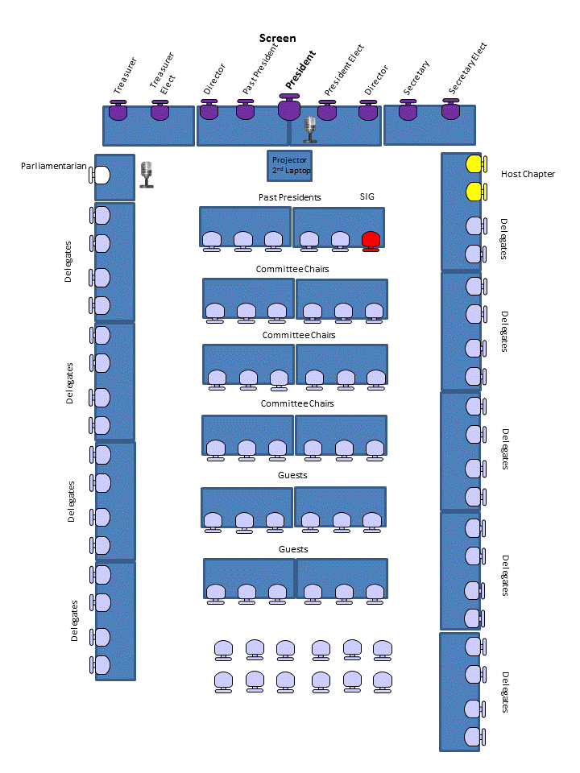

Appendix B (Board Meeting Room Setup)
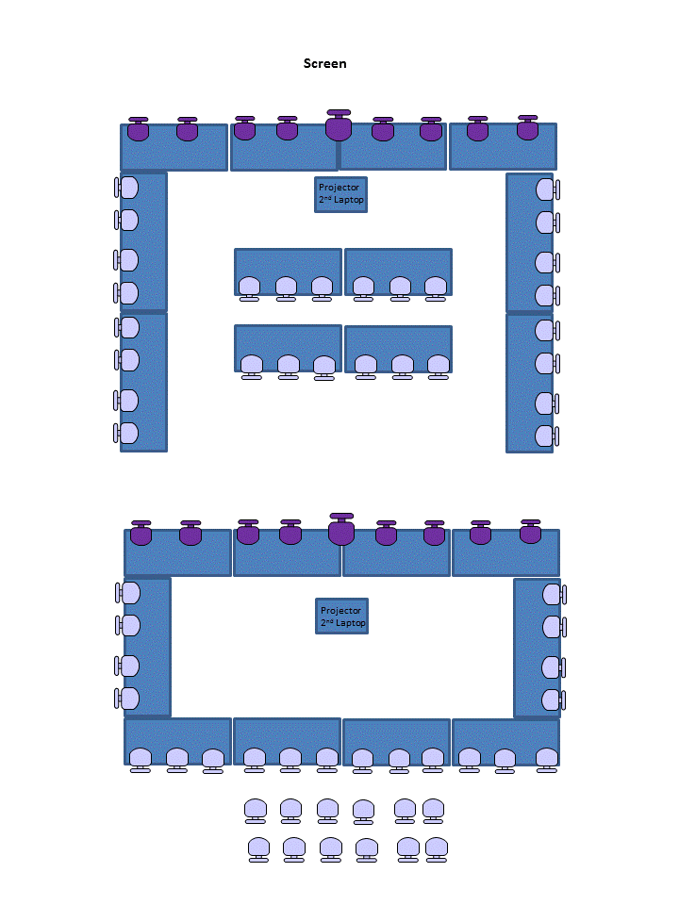
Example B
Example A

