TEXAS ENA COUNCIL 3rd QUARTER MEETING AGENDA

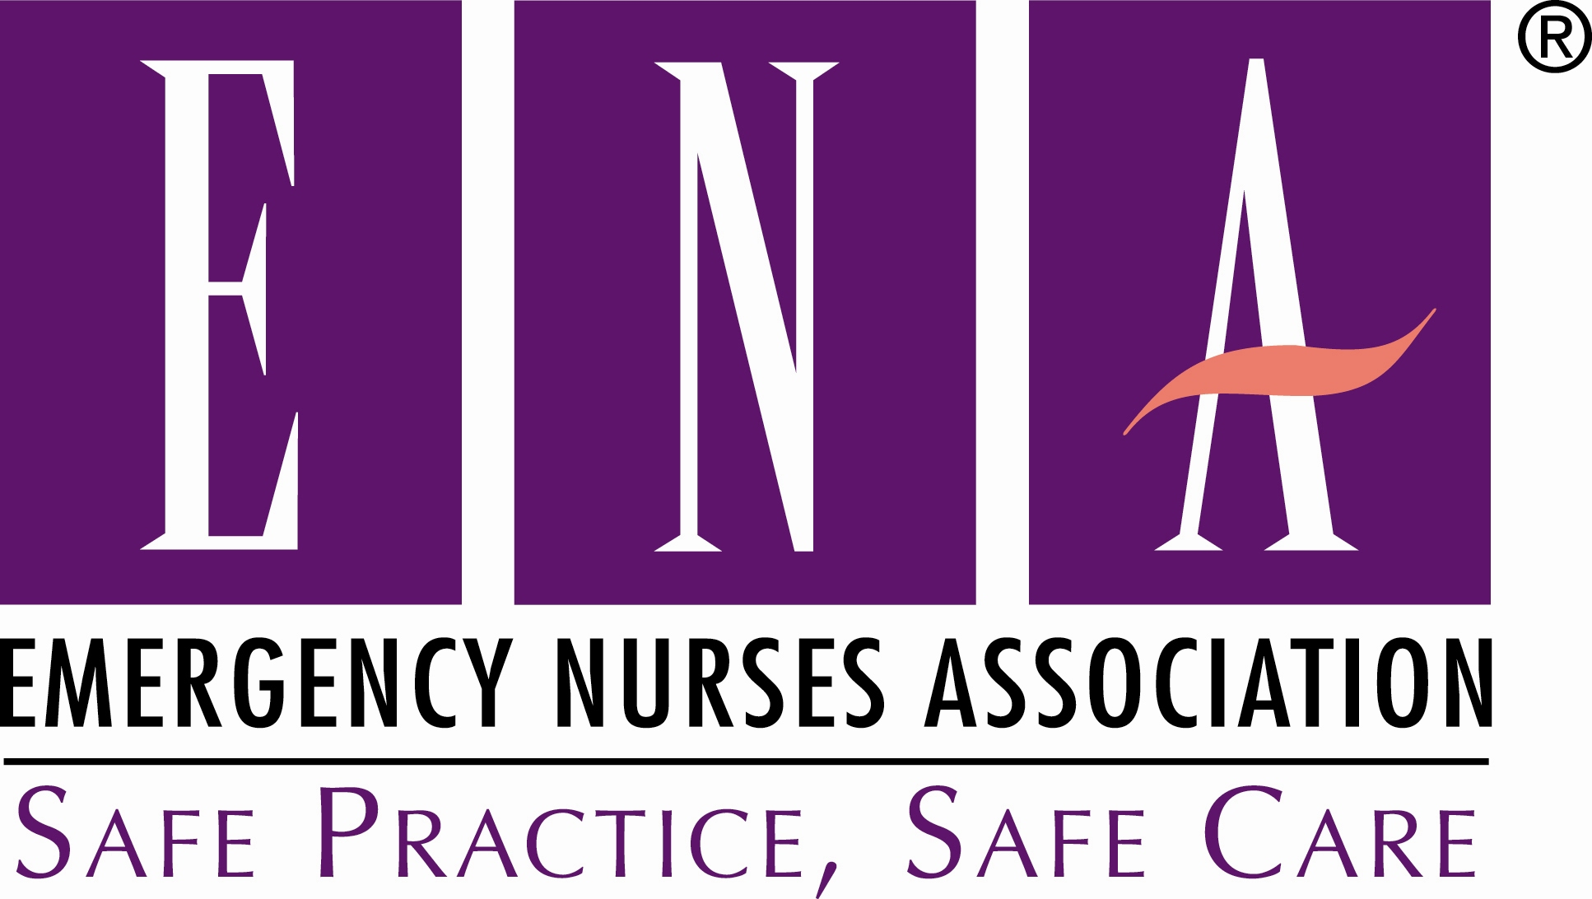 Texas ENA State Council Meeting
Amarillo, TX
July 11, 2015
Board Members:
Mary Leblond, President
Lynn Kelley, President-elect
Rhonda Manor-Coombes, Secretary
Vacant, Secretary-elect
Steven Jewell, Treasurer
Thomas Tierney, Director
Marcia Fuller, Director
Cam Brandt, Immediate Past President
Barry Hudson, Parliamentarian
ENA Board Liaison
State Chapter Delegates
Past State Presidents
Committee Chairs
AGENDA

Saturday July 11, 2015: 0900 – 1600
CALL TO ORDER ITEMS (10 minutes)
- Call to Order…………………………………………………………………………….……………………..Mary Leblond
- Invocation Barry Hudson
- Review of Roberts Rules of Order,, Current………………………………………………………Barry Hudson
- Official Delegate Count Barry Hudson
- Roll Call of Chapters
5. Approval of Agenda—Vote Required…………………..…………………………………..………......Delegates
6. Approval of Minutes —Vote Required………………………………………………………….……….Delegates
A. April 11, 2015 Meeting Minutes
BOARD AND CHAPTER REPORTS -80 minutes
7. Board Reports (3 minutes allowed per member)
A. Mary Leblond
B. Lynn Kelley
C. Rhonda Manor-Coombes
D. Steven Jewell
E. Marcia Fuller
F. Thomas Tierney
G. Cam Brandt
H. Barry Hudson

8. Chapter Updates (3min allowed per chapter)…………………….………………….……..Delegates

9. General Introductions
A. National Board Members Present
B. Past State Presidents
C. Committee Chairs
D. Members and Guests
E. Recognition of CEN, CPEN, CFRN, CTRN, and FAEN

BREAK (1053—1105)

ACTION SECTION—Votes Required

10. Treasurer’s Report ……………………………….….………………………………………….…..Steven Jewell
11. Special Election……………..…………………………………………………………………………Mary Leblond
12. Chapter ……………………………………………………………………………….Rhonda-Manor Coombes
13. Texas Voice Advertisement……………………………………….…………………………..Mary Leblond

14. LUNCH (1200—1300)
A. Round table discussions

INFORMATIONAL SECTION (5 minutes each
15. Happenings at Nationals………..……………………..…………………………………….…….Sally Snow
16. ENA National Conference Update…………………………….………….………….…………Kris Powell
17. 2015 State and Chapter Activity Plan………………………….………………………………Lynn Kelley
18. Governement Affairs………………………………………………………………………Valerie Brumfield
19. Chapter attendance/updates…………….………..……Cam Brandt/Rhonda Manor-Coombes
20. Website Changes…………………………….…………………..…………………Rhonda Manor-Coombes
21. State Council Achievement Award……………………….………………Cam Brandt/Mary Leblond

22. Committee Reports (5 min allowed for each unless noted)…….……….Committee Chairs

A. Bylaws and Standard Operating Procedures………………………………….….…Dan DiDonato
B. Delegate Selection……………………………………………………….……….…….…….….Barry Hudson
C. Injury Prevention………………………………………..…………………………………Courtney Edwards
D. Professional Education ………………………………….…………………………………...Carol Twombly
E. Pediatrics…………………………………………………………………………..……….…….…….Susan Raven
F. Government Affairs………………………….……………………………………….……Valerie Brumfield
G. Meetings Planning……………………….………………………….…….…………….…….…….Ingrid Steinbach
H. Resolutions………………………………………..……………………………………….…………………Scott Stover
I. Membership……………………………………………………………………….…………………….Pat Yancey
J. Nursing Practice…………………………………………………………………………..…………...Kris Powell
K. Emergency Preparedness…………………………………………………………………...……..Jeff Carico
L. Awards and Honors…………………………………………………………………………….…Rendi Bonner
M. Trauma…………………………………………………………………………….……..………..Christine Russe
N. Media/Press Secretary……………………………………………….………………..… Bobette Mayrant
O. Scholarship……………………………………………………………………..……………………Polly Johnson
P. Elections Process…………………………………….………………………………………………Cam Brandt
Q. Fundraising Committee………………………….…………..……….…Marcia Fuller/Tom Tierney

23. Member Open Discussion …………………………………………………………………………..…..……….All

24. Complete Assignments Table ……………………….…………...……………………..……Mary Leblond
25. Adjourn
Assignments Table
Item | Assigned To | Due Date

