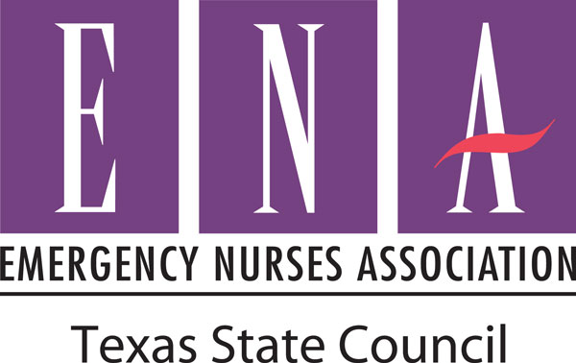

Date

Name
Address

Dear ___________________,

On behalf of the ______________ (local chapter name) of the Emergency Nurses Association, I would like to welcome you to ENA! The Emergency Nurses Association is the professional organization for emergency nurses nationwide. The mission of the Emergency Nurses Association is to advocate for patient safety and excellence in emergency nursing practice. Involvement in ENA offers professional practice resources, educational opportunities, networking with peers, and much more. We welcome you to our next meeting. I have included the meeting details below.

Meeting details:
Date:
Time:
Location:
Location Address:
Location Phone Number:

Please consider joining us to meet local ENA colleagues and begin networking with your peers. More information is available at _______________ (local chapter website).

Sincerely,

Name
Title
Contact information

