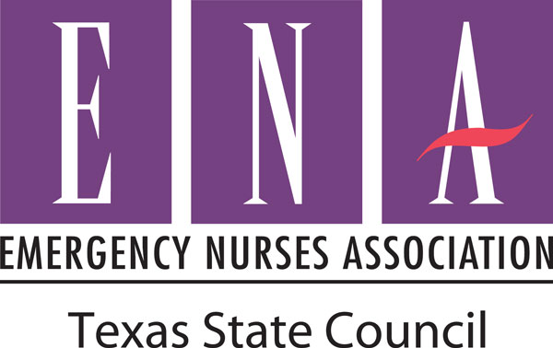

Date

Name
Address

Dear ___________________,

The Emergency Nurses Association is the professional organization for emergency nurses nationwide. The mission of the Emergency Nurses Association is to advocate for patient safety and excellence in emergency nursing practice. Your membership to the Emergency Nurses Association has expired and on behalf of the _______________ (local chapter name) of the Emergency Nurses Association I would like to invite you back and welcome you to our next meeting. I have included the meeting details below.

Meeting details:
Date:
Time:
Location:
Location Address:
Location Phone Number:

Involvement in ENA offers professional practice resources, educational opportunities, networking with peers, and much more. Please consider renewing your membership so you can take advantage of all these benefits. More information is available at _______________ (local chapter website) and www.ENA.org.

Sincerely,

Name
Title
Contact information

